



PROJECT REPORT

TASK FORCE

CONTENTS

1. Definition Of Problem 03
2. Requirements Analysis 03-05
3. Evaluation/Testing 05
4. Architecture of website design 05
5. Project Tracking and Monitoring Activities 06
6. Source code 03
7. User Guide 03
8. Site Map 03
9. Task Sheet 03
10. Our Journey 03

1.Definition of problem

“Soccer Verse ” is a soccer leagues website to be designed as a web design

If "soccer verse" is a term or concept that has become relevant in the context of website design frontend, I would recommend providing more information or context about what it entails. This could include details about its purpose, features, target audience, or any unique aspects that set it apart from other website designs.

Additionally, problem-solving on a soccer website extends beyond technical aspects. It also encompasses identifying user pain points and addressing them through intuitive design choices, clear communication channels for support or inquiries, and relevant content that caters to different levels of interest or expertise

2. Requirements Analysis

* List of inputs to the system

User Feedback Data

* Usernames
* Email addresses
* Feedback and appreciation to the player

In this website, Soccer Verse, an Example of outputs would be player Statistics Data

* Hardware and Software requirements for implementing the project

# **Hardware**

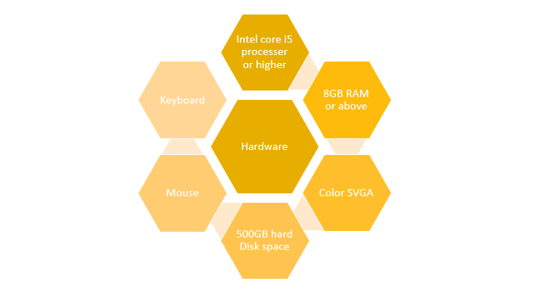

# **Software**

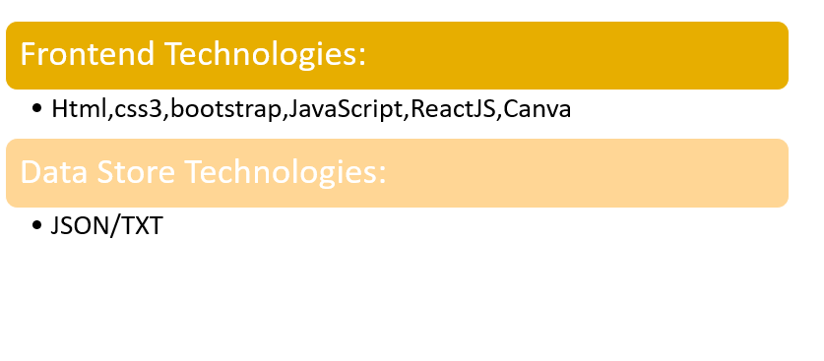

* Customer’s acceptance of the criteria for the project

The acceptance criteria could be following

1. Current Live score
2. User Favorite Player Biographies
3. Past Result

3. Evaluation/Testing

When it comes to designing a soccer website, evaluation and testing play a crucial role in ensuring its effectiveness and success. Evaluating and testing the design allows you to gather valuable insights and feedback, helping you make informed decisions to improve the user experience and achieve your website's goals.

4. Architecture of the website

* Data flow Diagram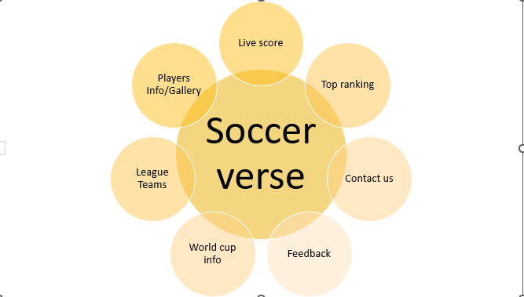

5. Project Tracking and Monitoring

Muhammad Urwah, Hassan Raza Lakhani, Muskan, and Fatima worked on Frontend and JSON files & Documentation.

Monitored During the whole project by Sir Azhar.

6. Source code

7. User Guide

A) System Requirement

8.Site Map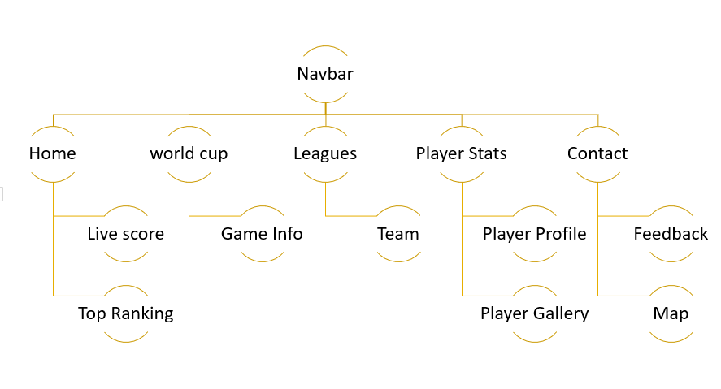

9.TaskSheet

| **Name** | **Task** | **Update** |
| --- | --- | --- |
| Fatima  (Frontend) | |  | | --- | | Logo design | | Feedback Form | | Live score layout | | Top Ranking layout | | Readme file  JSON File | | Completed |
| Muskan  (Frontend) | |  | | --- | | Documentation | | Footer | | Prototype | | Site map | | completed |
| Hassan  (Frontend) | |  | | --- | | Navbar | | contact us | | Graphics | | Completed |
| Muhammad  Urwah  (Frontend) | |  | | --- | | Player, club, league  Researching | |  | |  | | Completed |
|  |  |  |

10. Our Journey of Techwiz 4

Aptech has been one of the front-runners in IT education

During the 3 days of the Techwiz Competition, we got to learn Extraordinarily. The project assigned was challenging and fun. Another excellent point is we were grouped with the Student of Other Batches & got to learn from each other.

Our faculty member guided us throughout the project and monitored our tasks

Concluding, we would like to thank Aptech for coming up with this great project idea.

At TECHWIZ we had an amazing experience